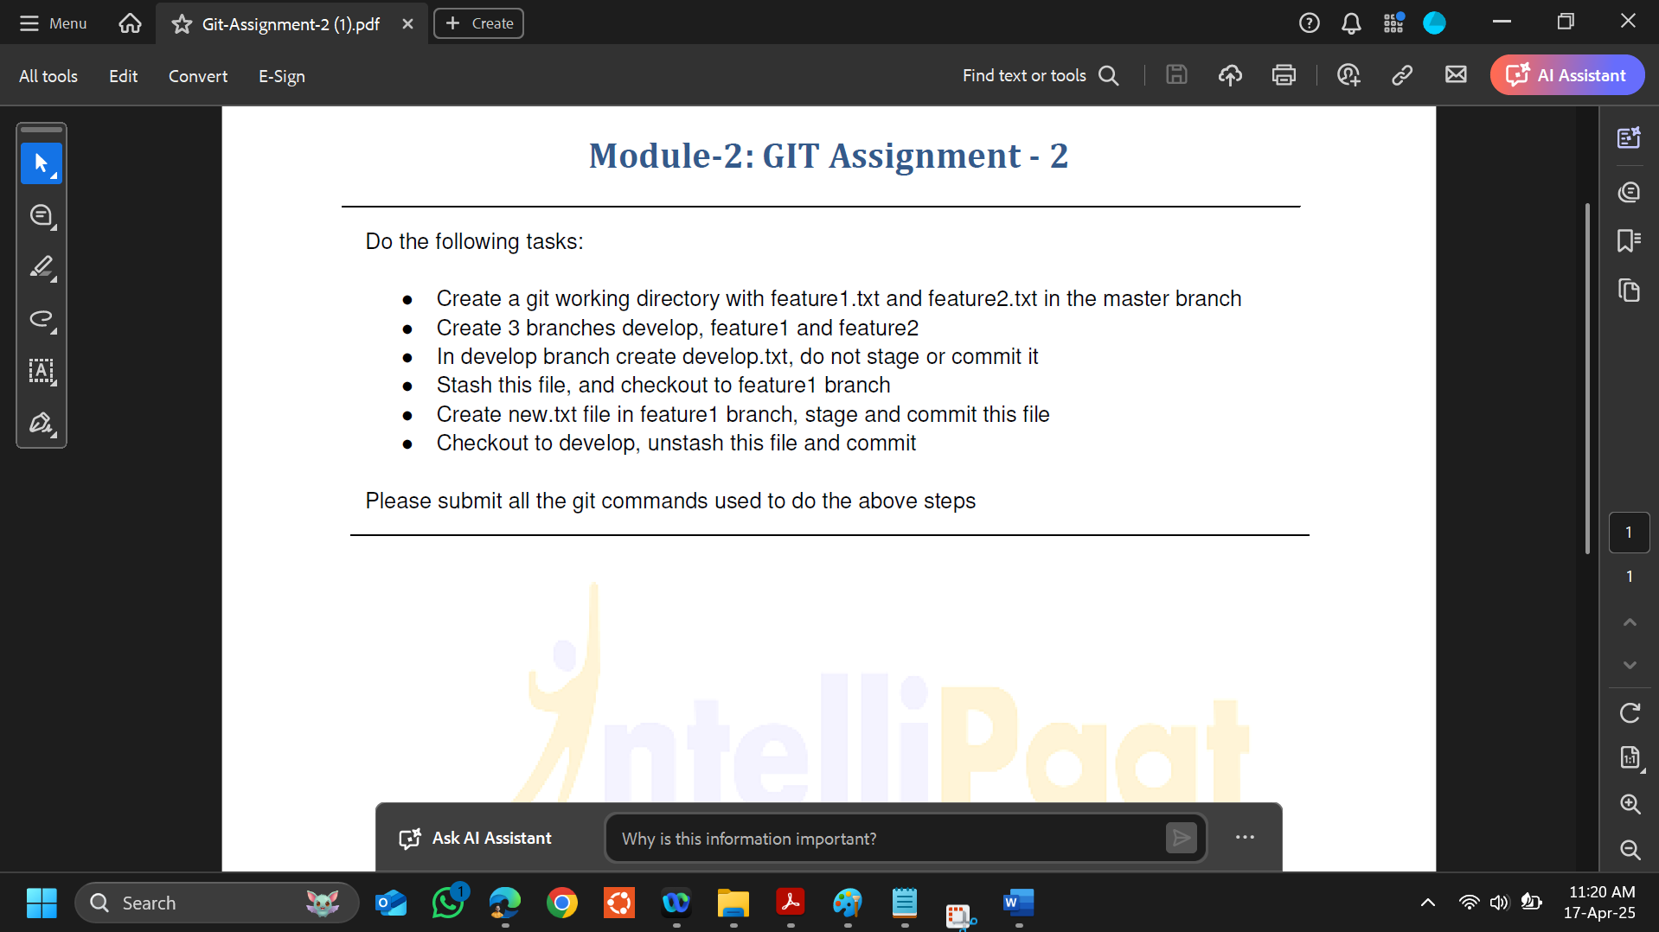

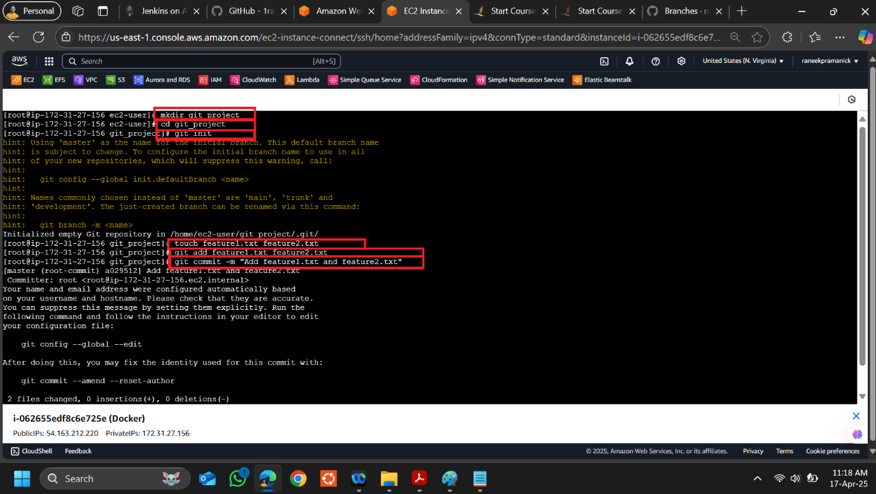

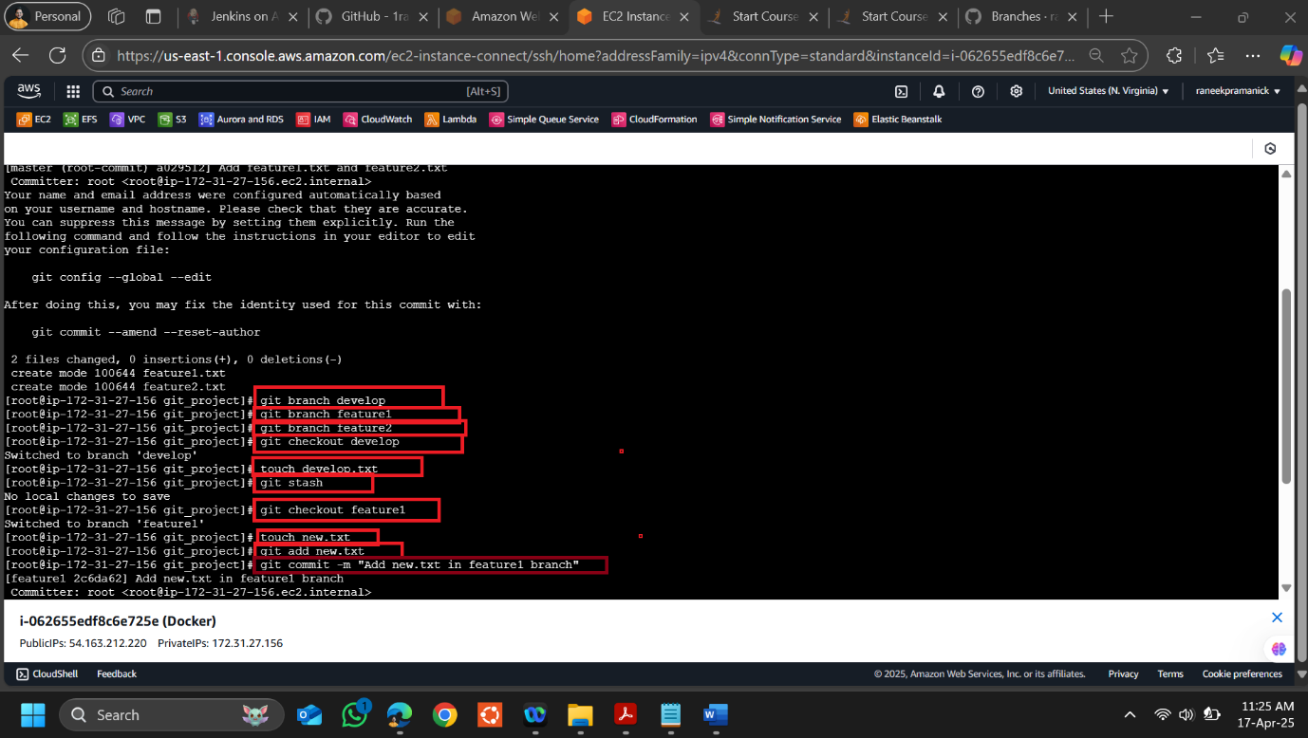

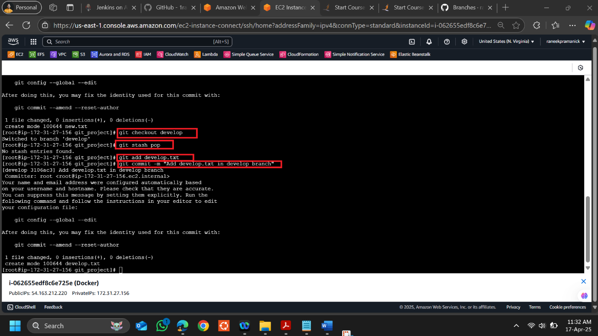

**Please find all the command used in this assignment below-**

# Step 1: Initialize a new Git repository and create the working directory

mkdir git_project & cd git_project

git init

# Step 2: Create feature1.txt and feature2.txt in the master branch

touch feature1.txt feature2.txt

git add feature1.txt feature2.txt

git commit -m "Add feature1.txt and feature2.txt"

# Step 3: Create three branches: develop, feature1, and feature2

git branch develop

git branch feature1

git branch feature2

# Step 4: Checkout to the develop branch and create develop.txt

git checkout develop

touch develop.txt # Do not stage or commit this file

# Step 5: Stash develop.txt and checkout to feature1 branch

git stash

git checkout feature1

# Step 6: Create new.txt file in feature1 branch, stage and commit it

touch new.txt

git add new.txt

git commit -m "Add new.txt in feature1 branch"

# Step 7: Checkout back to develop branch, unstash develop.txt and commit it

git checkout develop

git stash pop

git add develop.txt

git commit -m "Add develop.txt in develop branch"